Execute and display the results for the following commands in Kali Linux Operating
Systems:

rm command
users command
tree command
Aim:
To execute and understand the basic Linux commands rm, users, and tree in the Kali Linux operating system.
- rm command:
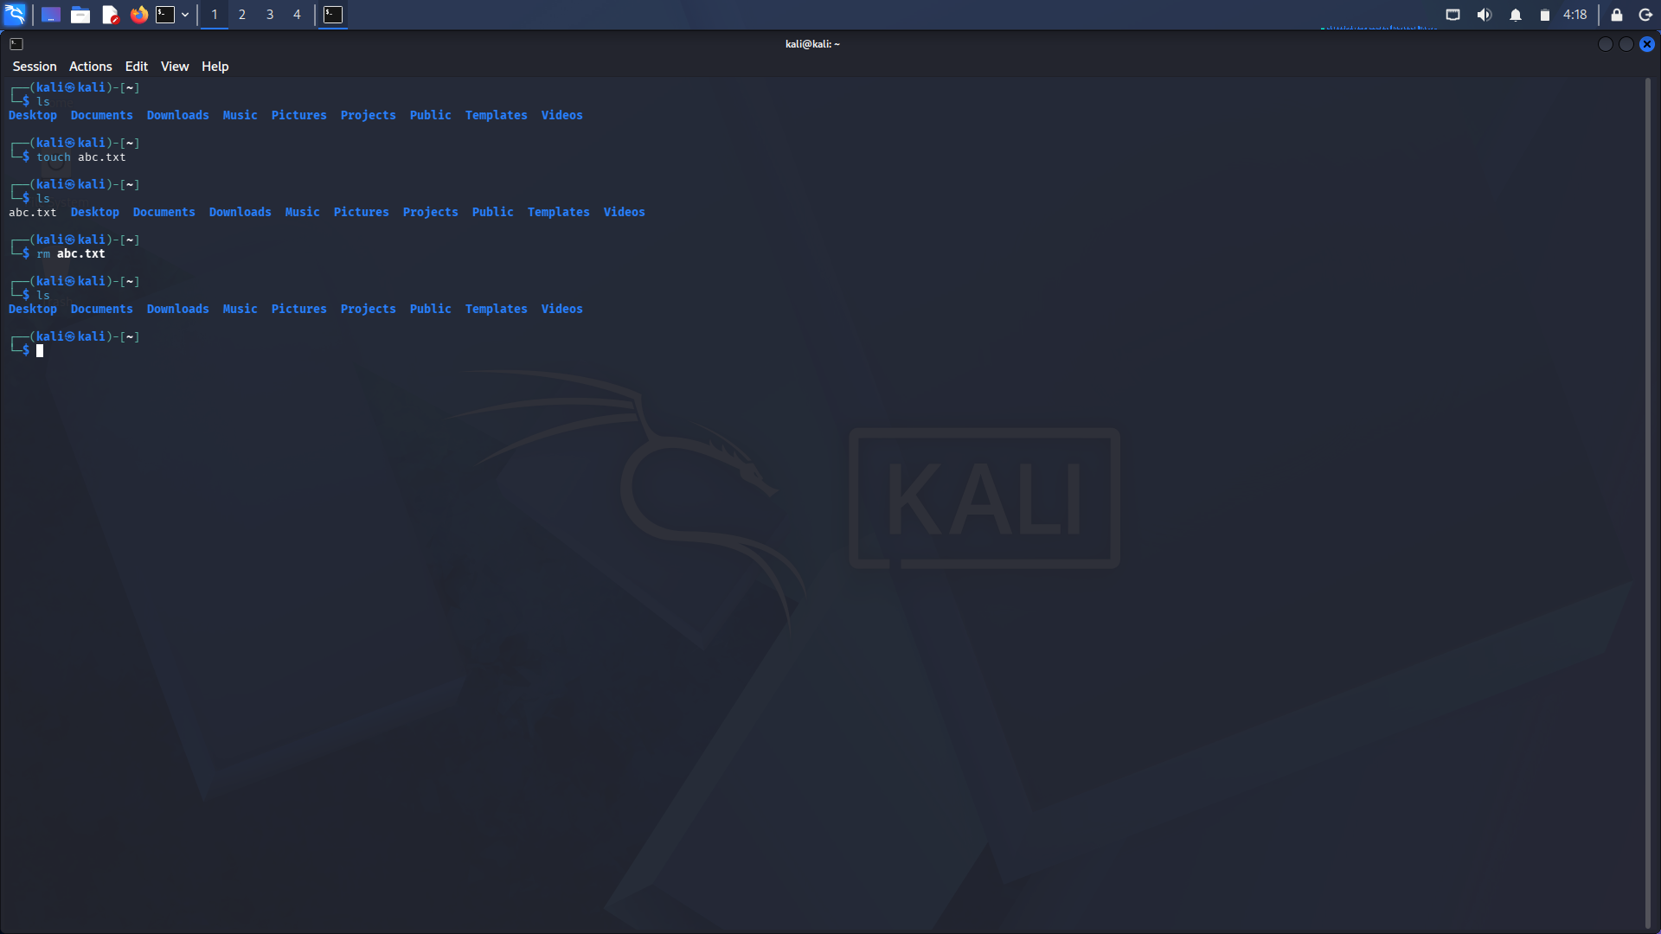

- users command:

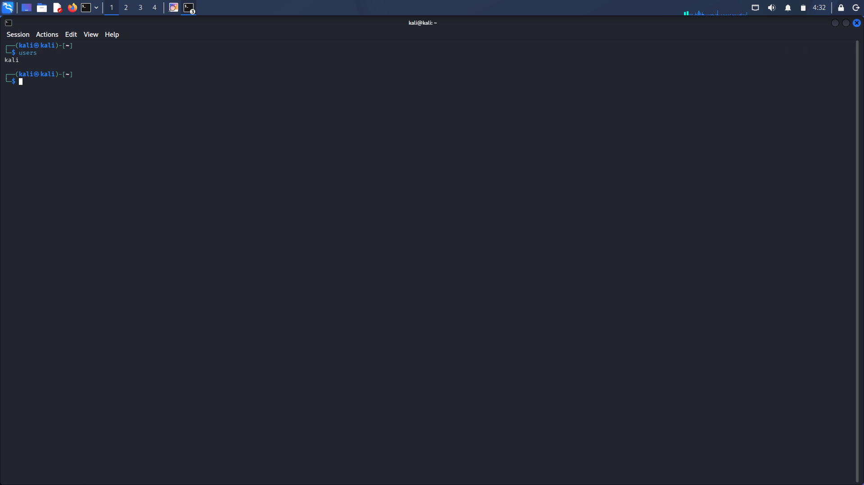

- tree
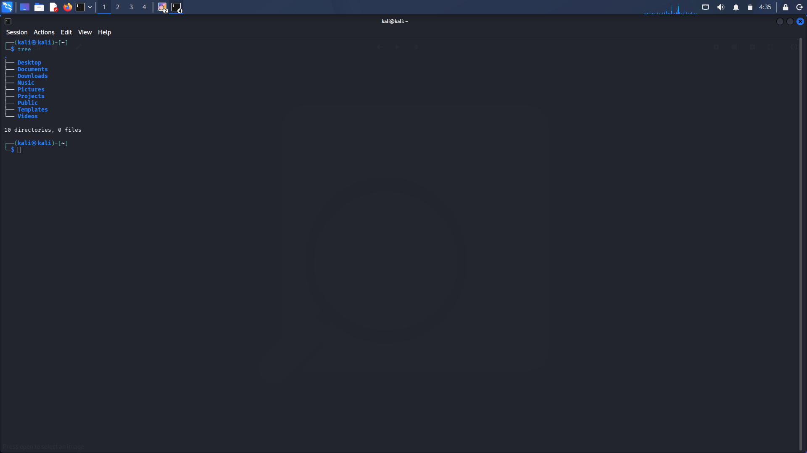

Result
The rm, users, and tree commands were successfully executed in Kali Linux, and their respective functions were observed and verified.

